CREATE TABLE EMPPLOY (

EMPLOYEE_ID NUMBER(10) PRIMARY KEY,

FIRST_NAME VARCHAR2(50),

LAST_NAME VARCHAR2(50),

DEPARTMENT VARCHAR2(50),

SALARY NUMBER(10, 2)

);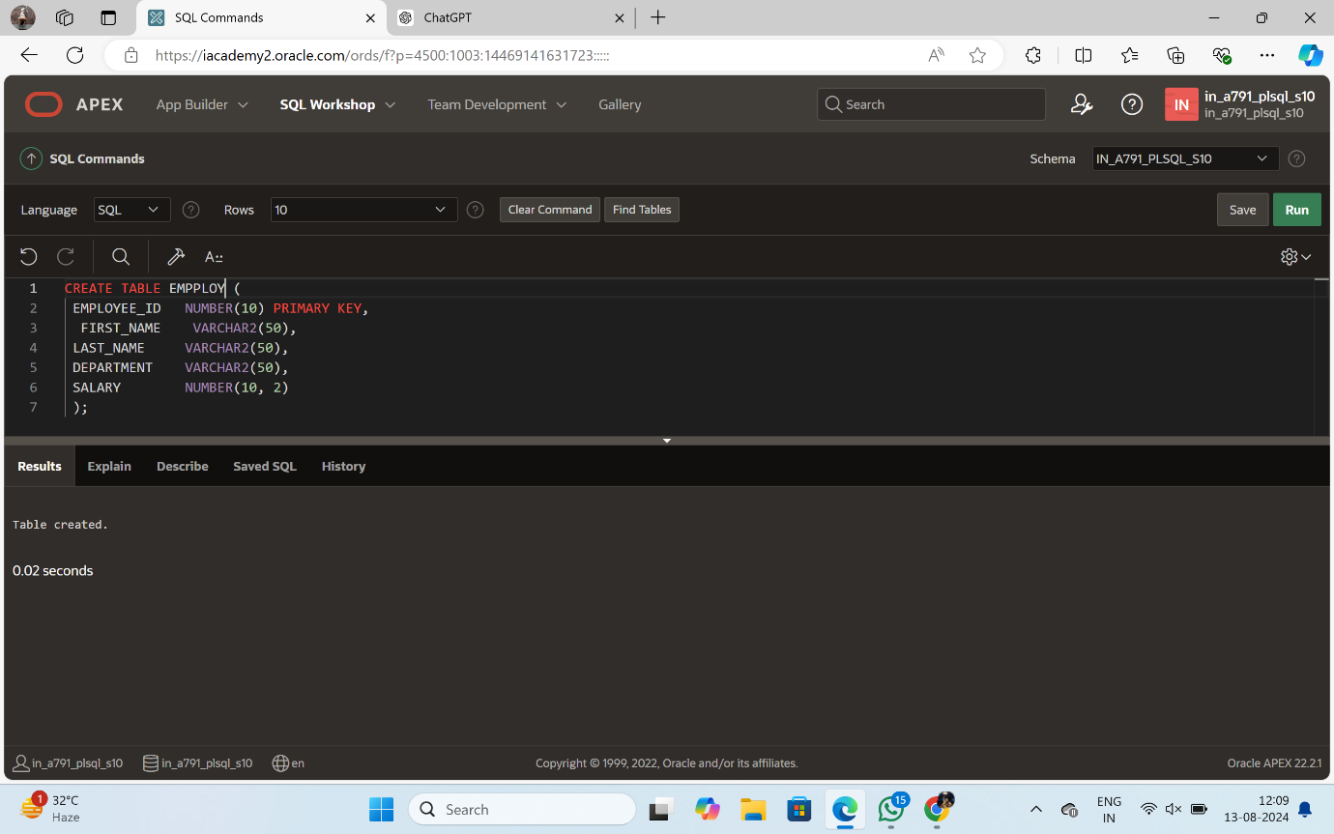

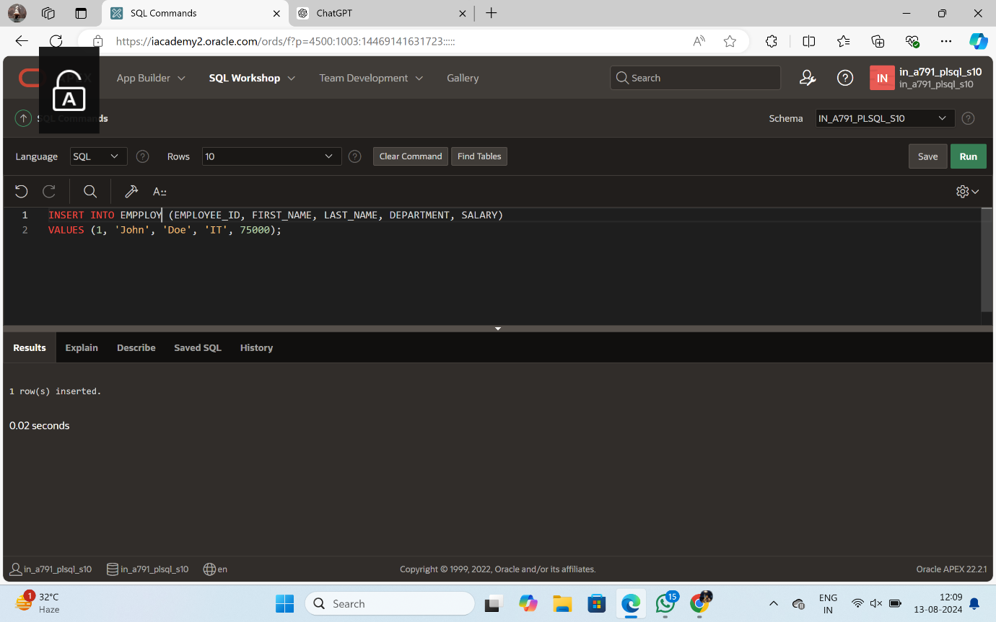

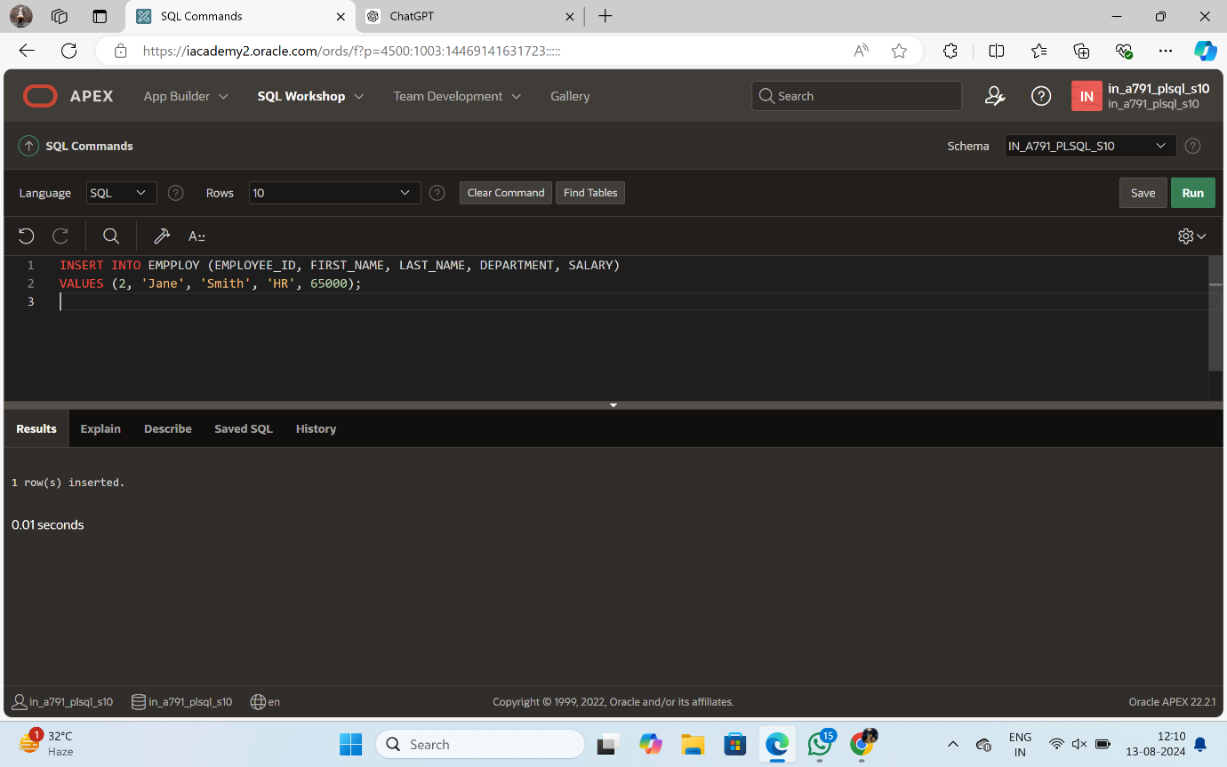

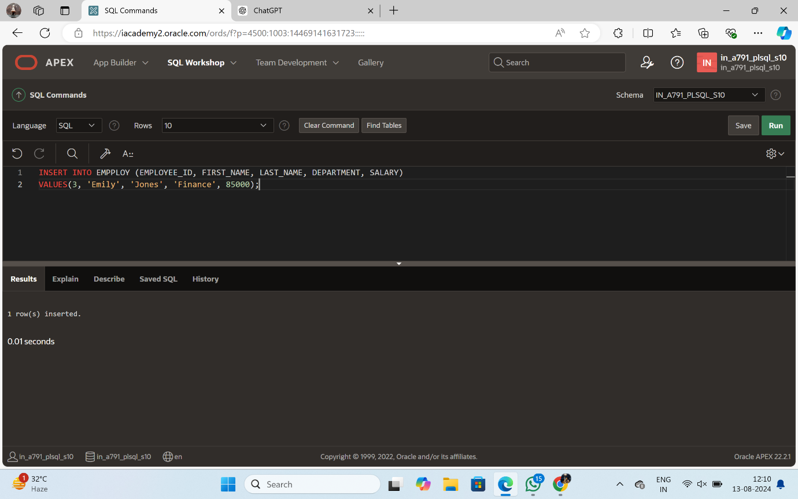INSERT INTO EMPPLOY(EMPLOYEE_ID, FIRST_NAME, LAST_NAME, DEPARTMENT, SALARY)

VALUES (1, 'John', 'Doe', 'IT', 75000);

(2, 'Jane', 'Smith', 'HR', 65000);

(3, 'Emily', 'Jones', 'Finance', 85000);

(4, 'Michael', 'Brown', 'IT', 72000);

(5, 'Jessica', 'Taylor', 'Marketing', 60000);

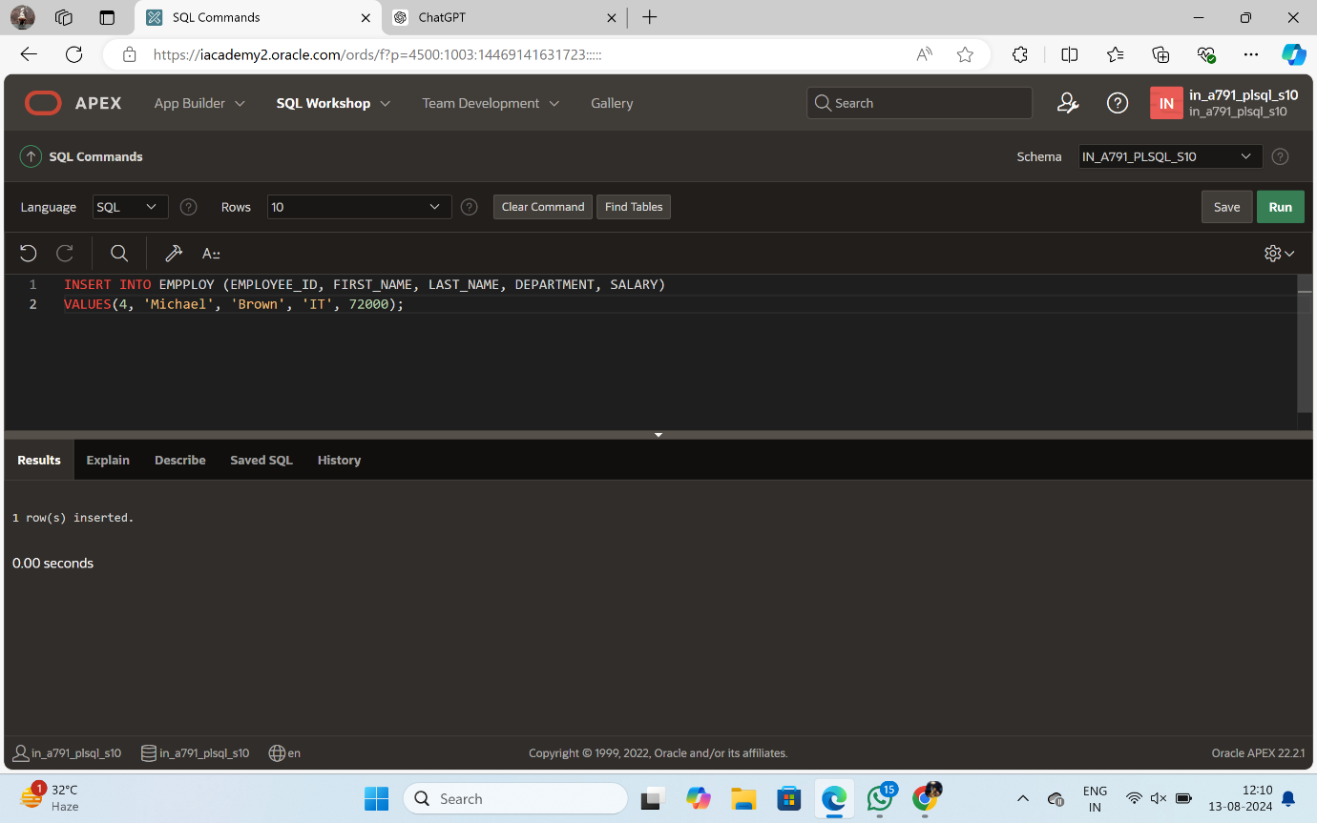

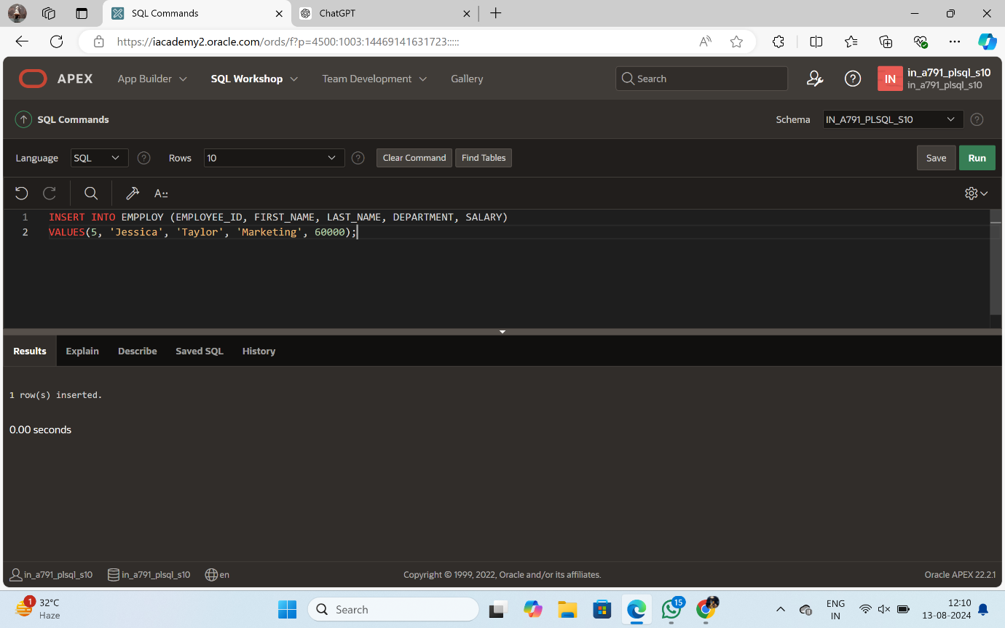

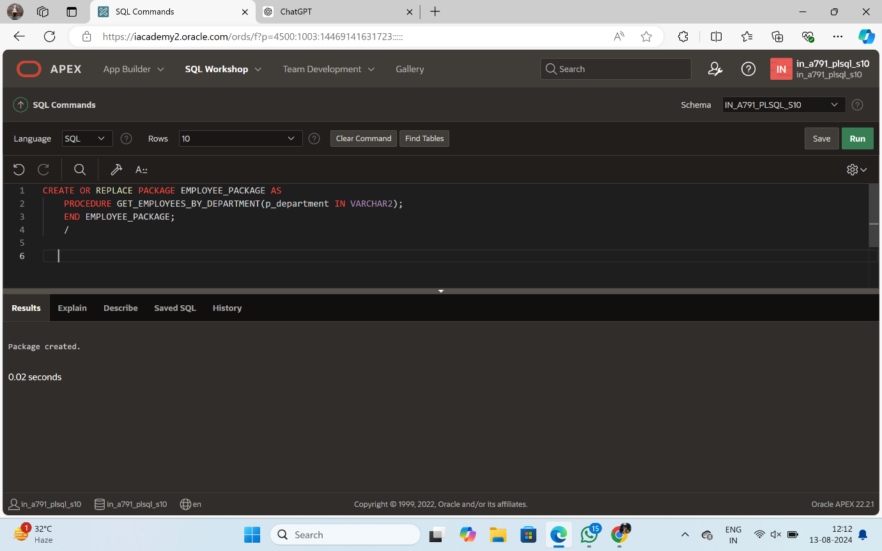CREATE OR REPLACE PACKAGE EMPLOYEE_PACKAGE AS

PROCEDURE GET_EMPLOYEES_BY_DEPARTMENT(p_department IN VARCHAR2);

END EMPLOYEE_PACKAGE;

/

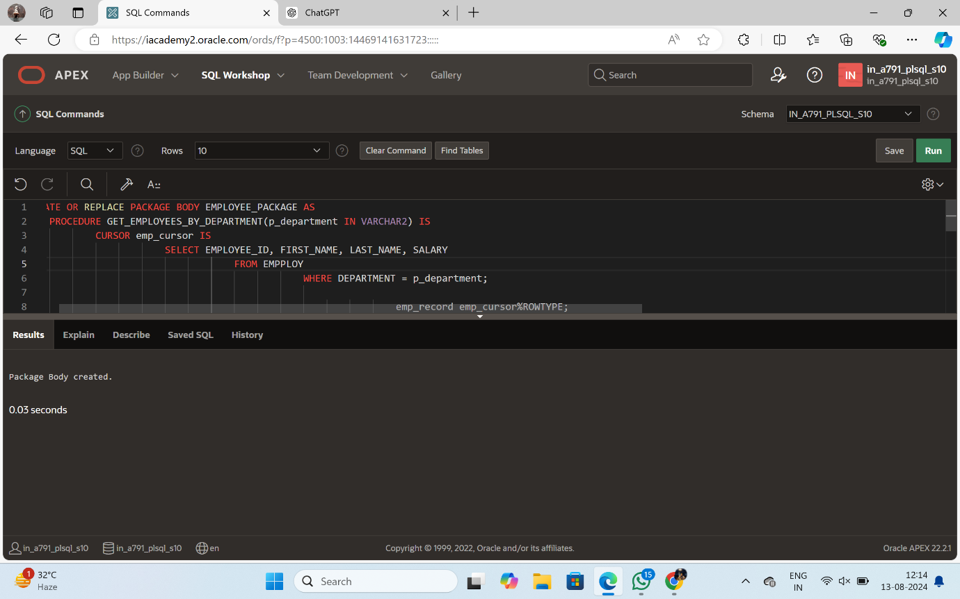CREATE OR REPLACE PACKAGE BODY EMPLOYEE_PACKAGE AS

PROCEDURE GET_EMPLOYEES_BY_DEPARTMENT(p_department IN VARCHAR2) IS

CURSOR emp_cursor IS

SELECT EMPLOYEE_ID, FIRST_NAME, LAST_NAME, SALARY

FROM EMPPLOY

WHERE DEPARTMENT = p_department;

emp_record emp_cursor%ROWTYPE;

BEGIN

OPEN emp_cursor;

LOOP

FETCH emp_cursor INTO emp_record;

EXIT WHEN emp_cursor%NOTFOUND;

DBMS_OUTPUT.PUT_LINE('ID: ' || emp_record.EMPLOYEE_ID ||

', Name: ' || emp_record.FIRST_NAME || ' ' || emp_record.LAST_NAME ||

', Salary: ' || emp_record.SALARY);

END LOOP;

CLOSE emp_cursor;

END GET_EMPLOYEES_BY_DEPARTMENT;

END EMPLOYEE_PACKAGE;

/

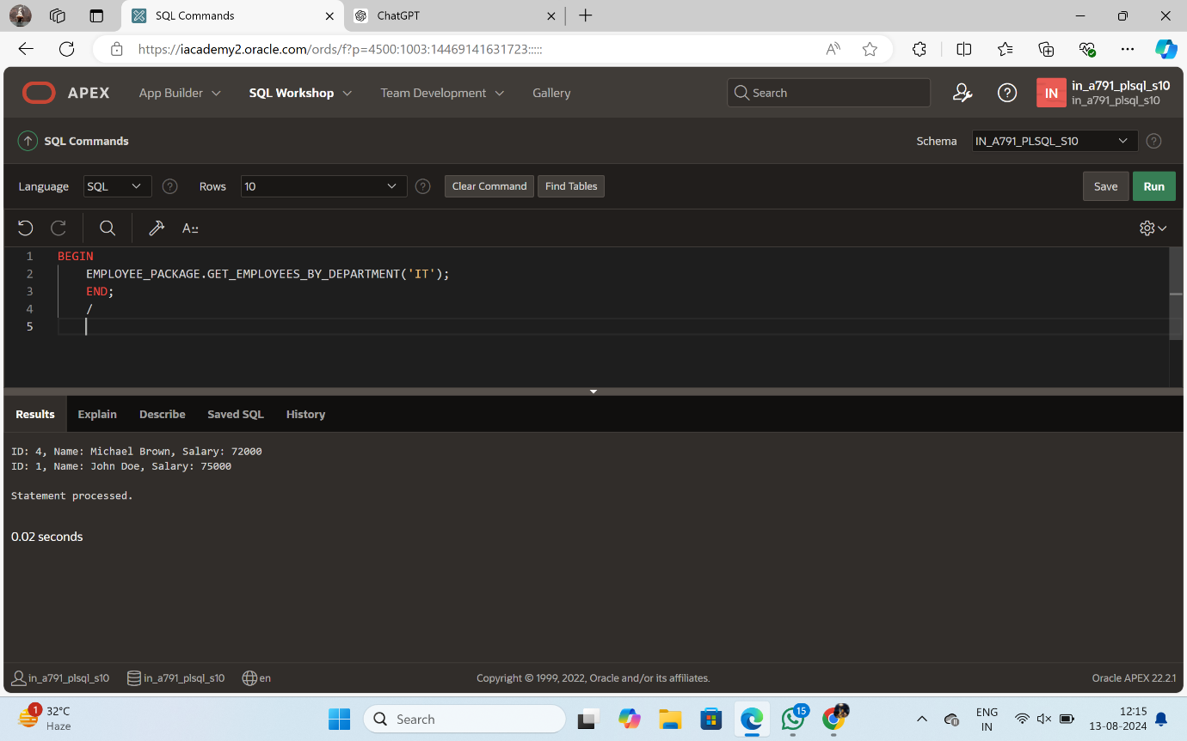

BEGIN

EMPLOYEE_PACKAGE.GET_EMPLOYEES_BY_DEPARTMENT('IT');

END;

/